1. 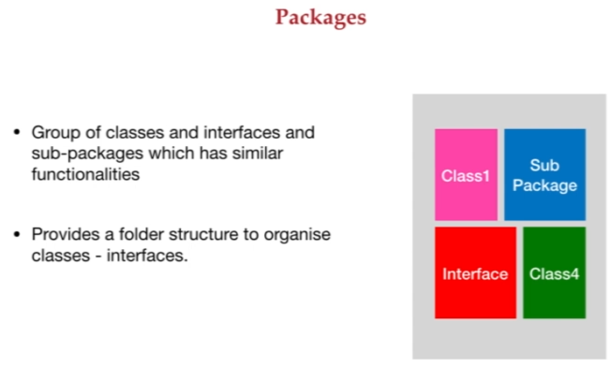
2. **Package**: To avoid naming-conflict.